Closed Shapes
# Source: AI Source: Provided by: [Data Path: Persons Table -> ID Column: 1, Name_En Column: Motasem Essam] -> From: [ChatGPT] on [7/25/2026]
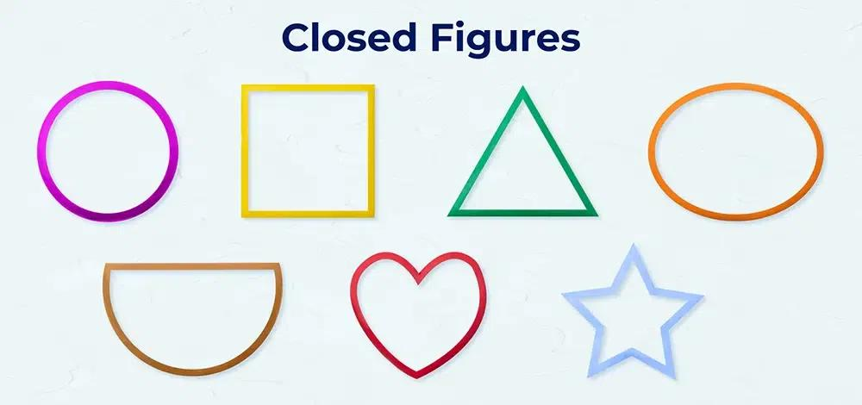
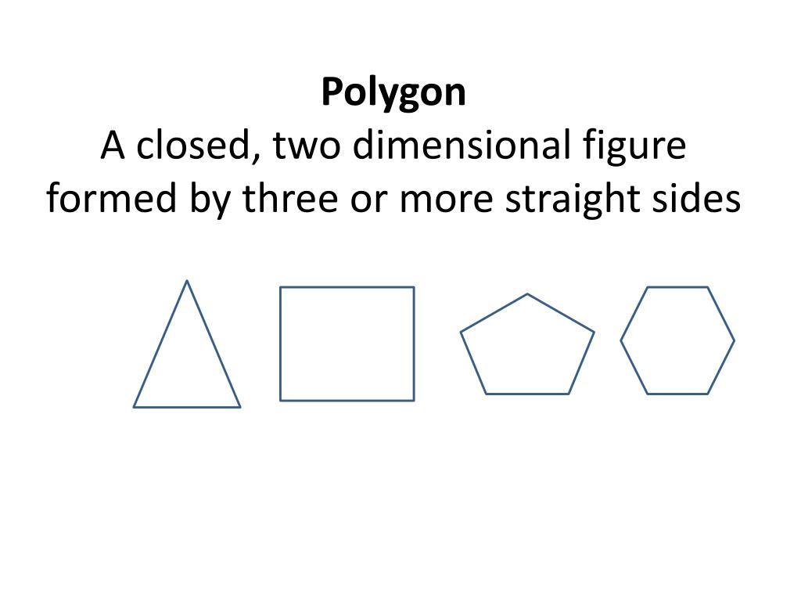
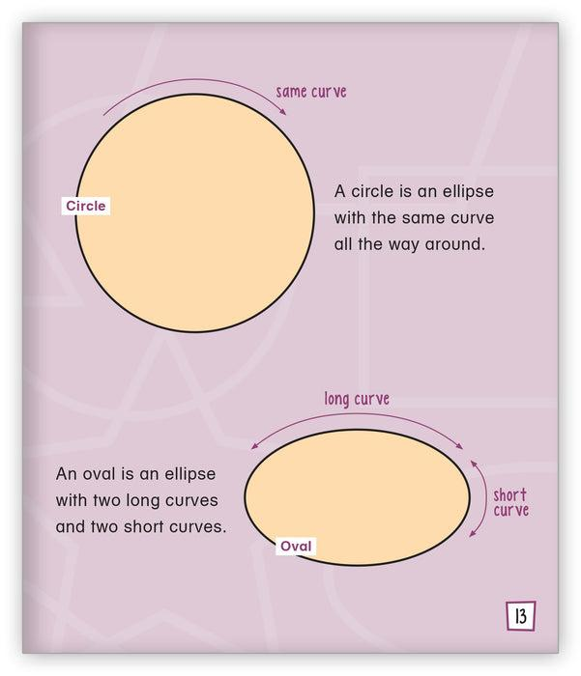
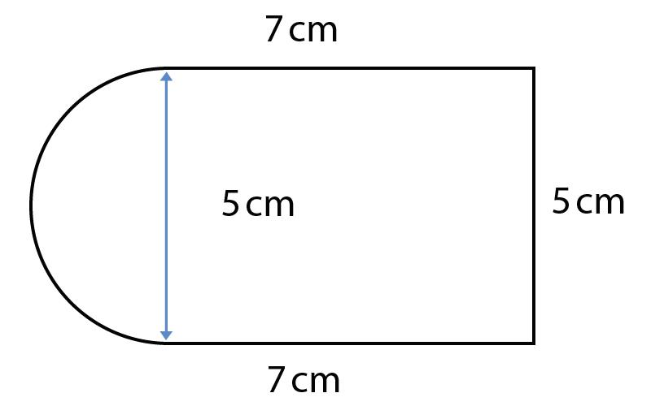
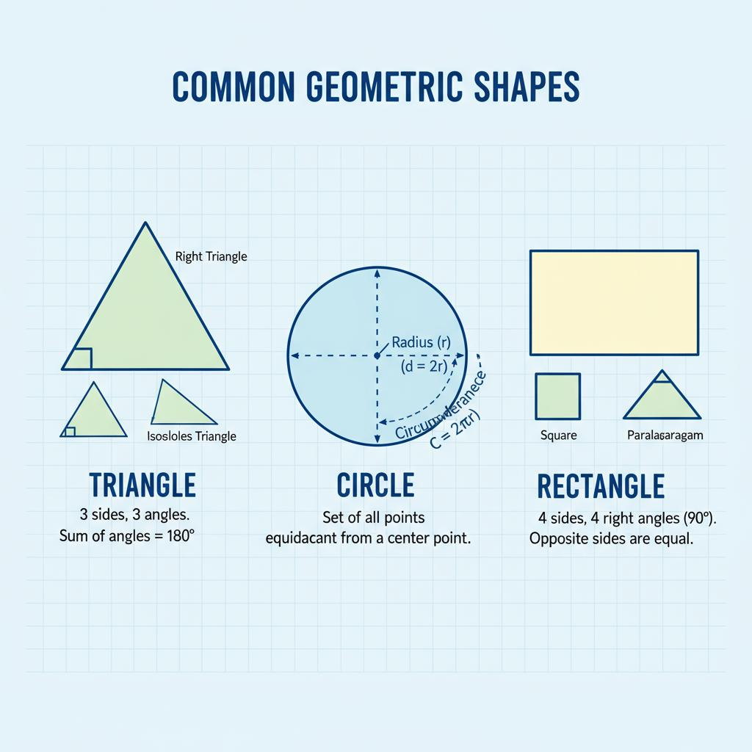

Definition
# Source: AI Source: Provided by: [Data Path: Persons Table -> ID Column: 1, Name_En Column: Motasem Essam] -> From: [ChatGPT] on [7/25/2026]
A Closed Shape is a two-dimensional geometric figure whose boundary forms a complete loop with no gaps or openings. The starting point and ending point of the boundary meet, creating a fully enclosed figure.
A closed shape separates the plane into:
- Interior Region – The area inside the shape.
- Boundary – The edge of the shape.
- Exterior Region – The area outside the shape.

Characteristics
# Source: AI Source: Provided by: [Data Path: Persons Table -> ID Column: 1, Name_En Column: Motasem Essam] -> From: [ChatGPT] on [7/25/2026]
A closed shape:
- Has a complete boundary.
- Has no open endpoints.
- Encloses an interior region.
- Has measurable area.
- Has measurable perimeter.
- Can be regular or irregular.
- Can be polygonal, curved, or mixed.

Illustration

Closed Polygonal Shape (Square)
# Source: AI Source: Provided by: [Data Path: Persons Table -> ID Column: 1, Name_En Column: Motasem Essam] -> From: [ChatGPT] on [7/25/2026]
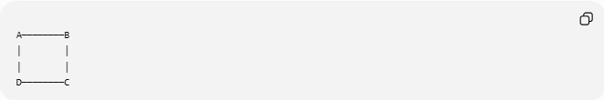
A────────B
│ │
│ │
D────────C
The four sides connect completely.

Closed Curved Shape (Circle)
# Source: AI Source: Provided by: [Data Path: Persons Table -> ID Column: 1, Name_En Column: Motasem Essam] -> From: [ChatGPT] on [7/25/2026]
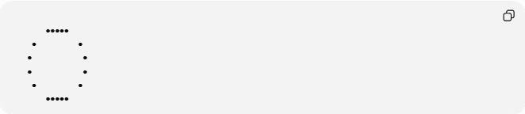
●●●●●
● ●
● ●
● ●
● ●
●●●●●
The circumference forms a closed curve.

Closed Mixed Shape
# Source: AI Source: Provided by: [Data Path: Persons Table -> ID Column: 1, Name_En Column: Motasem Essam] -> From: [ChatGPT] on [7/25/2026]
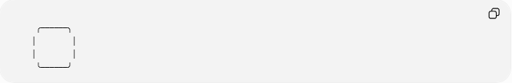
╭──────╮
│ │
│ │
╰──────╯
A combination of curved and straight boundaries.

Mathematical Representation
# Source: AI Source: Provided by: [Data Path: Persons Table -> ID Column: 1, Name_En Column: Motasem Essam] -> From: [ChatGPT] on [7/25/2026]
A closed shape can be represented as a set of points:
$S=\{\left(x,y\right)∣\left(x,y\right)\text{ lies inside or on the boundary}$}
The boundary is:
$$∂S$$
For a closed shape:
$$\text{Starting Point}=\text{Ending Point}$$

Types of Closed Shapes

1. Closed Polygonal Shapes
# Source: AI Source: Provided by: [Data Path: Persons Table -> ID Column: 1, Name_En Column: Motasem Essam] -> From: [ChatGPT] on [7/25/2026]
Shapes formed only by straight line segments.
Examples:
- Triangle
- Square
- Rectangle
- Pentagon
- Hexagon

2. Closed Curved Shapes
# Source: AI Source: Provided by: [Data Path: Persons Table -> ID Column: 1, Name_En Column: Motasem Essam] -> From: [ChatGPT] on [7/25/2026]
Shapes formed entirely by curves.
Examples:
- Circle
- Ellipse
- Oval

3. Closed Mixed Shapes
# Source: AI Source: Provided by: [Data Path: Persons Table -> ID Column: 1, Name_En Column: Motasem Essam] -> From: [ChatGPT] on [7/25/2026]
Shapes containing both straight and curved boundaries.
Examples:
- Semicircle with diameter
- Stadium shape
- Rounded rectangle

Classification by Properties
# Source: AI Source: Provided by: [Data Path: Persons Table -> ID Column: 1, Name_En Column: Motasem Essam] -> From: [ChatGPT] on [7/25/2026]
Regular Closed Shapes
Have:
- Equal sides.
- Equal angles.
Examples:
- Square.
- Equilateral triangle.
- Regular hexagon.

Irregular Closed Shapes
# Source: AI Source: Provided by: [Data Path: Persons Table -> ID Column: 1, Name_En Column: Motasem Essam] -> From: [ChatGPT] on [7/25/2026]
Have:
- Unequal sides and/or angles.
Examples:
- Scalene triangle.
- Irregular polygon.
- Natural closed shapes.

Closed Shape vs Open Shape
# Source: AI Source: Provided by: [Data Path: Persons Table -> ID Column: 1, Name_En Column: Motasem Essam] -> From: [ChatGPT] on [7/25/2026]
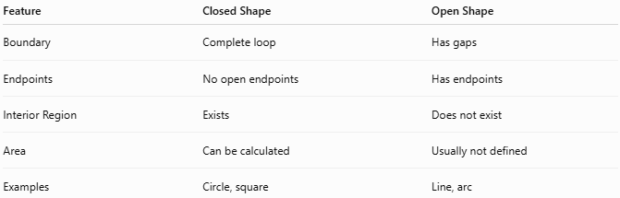
Feature | Closed Shape | Open Shape
Boundary | Complete loop | Has gaps
Endpoints | No open endpoints | Has endpoints
Interior Region | Exists | Does not exist
Area | Can be calculated | Usually not defined
Examples | Circle, square | Line, arc

Area and Perimeter
# Source: AI Source: Provided by: [Data Path: Persons Table -> ID Column: 1, Name_En Column: Motasem Essam] -> From: [ChatGPT] on [7/25/2026]
Because closed shapes enclose regions, they have:
Area
The amount of space inside the shape.
Examples:
Rectangle:
$$A=l×w$$
Triangle:
$$A=\frac{1}{2}bh$$
Circle:
$$A=πr^{2}$$

Perimeter
The total length of the boundary.
Examples:
Square:
$$P=4s$$
Rectangle:
$$P=2\left(l+w\right)$$
Circle:
$$C=2πr$$

Real-World Examples
# Source: AI Source: Provided by: [Data Path: Persons Table -> ID Column: 1, Name_En Column: Motasem Essam] -> From: [ChatGPT] on [7/25/2026]
Closed shapes appear in:
- Doors.
- Windows.
- Rooms.
- Tables.
- Coins.
- Plates.
- Road signs.
- Sports fields.
- Buildings.
- Land boundaries.
- Product designs.

Applications
# Source: AI Source: Provided by: [Data Path: Persons Table -> ID Column: 1, Name_En Column: Motasem Essam] -> From: [ChatGPT] on [7/25/2026]
Closed shapes are used in:
- Plane Geometry
- Coordinate Geometry
- Engineering
- Architecture
- Surveying
- CAD (Computer-Aided Design)
- GIS (Geographic Information Systems)
- Computer Graphics
- Robotics
- Manufacturing

Advantages
# Source: AI Source: Provided by: [Data Path: Persons Table -> ID Column: 1, Name_En Column: Motasem Essam] -> From: [ChatGPT] on [7/25/2026]
Studying closed shapes helps to:
- Calculate area and perimeter.
- Define enclosed spaces.
- Analyze geometric properties.
- Create designs and models.
- Understand boundaries and regions.

Limitations
# Source: AI Source: Provided by: [Data Path: Persons Table -> ID Column: 1, Name_En Column: Motasem Essam] -> From: [ChatGPT] on [7/25/2026]
Closed shapes:
- Cannot represent open paths.
- May become complex if irregular.
- Sometimes require advanced methods for area calculation.

Comparison with Shape Classifications
# Source: AI Source: Provided by: [Data Path: Persons Table -> ID Column: 1, Name_En Column: Motasem Essam] -> From: [ChatGPT] on [7/25/2026]
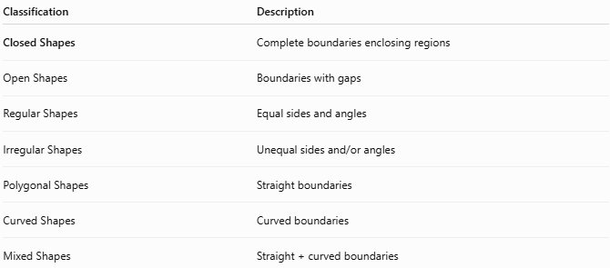
Classification | Description
Closed Shapes | Complete boundaries enclosing regions
Open Shapes | Boundaries with gaps
Regular Shapes | Equal sides and angles
Irregular Shapes | Unequal sides and/or angles
Polygonal Shapes | Straight boundaries
Curved Shapes | Curved boundaries
Mixed Shapes | Straight + curved boundaries

Key Points
# Source: AI Source: Provided by: [Data Path: Persons Table -> ID Column: 1, Name_En Column: Motasem Essam] -> From: [ChatGPT] on [7/25/2026]
- A Closed Shape has a complete boundary.
- The first and last points meet.
- It encloses an interior region.
- It has measurable:
  - Area
  - Perimeter
- Examples include:
  - Circle
  - Square
  - Triangle
  - Rectangle
  - Ellipse
  - Rounded rectangle

Conclusion
# Source: AI Source: Provided by: [Data Path: Persons Table -> ID Column: 1, Name_En Column: Motasem Essam] -> From: [ChatGPT] on [7/25/2026]
A Closed Shape is a two-dimensional geometric figure whose boundary forms a complete loop without gaps. It encloses an interior region and has measurable properties such as area and perimeter. Closed shapes are fundamental in plane geometry, coordinate geometry, engineering, architecture, surveying, CAD, GIS, computer graphics, robotics, and design, where they are used to represent enclosed spaces, analyze geometric structures, and model real-world objects.

